**PROJECT REPORT**

**ON**

AIRPORT MANAGEMENT SYSTEM

**INDEX**

|  |  |
| --- | --- |
| **Sr. No.** | **Contents** |
| **1** | **Introduction** |
| **2** | **Theory** |
| **3** | **ER DIAGRAM** |
| **4** | **ER RELATIONSHIP** |
| **5** | **RELATIONAL DIAGRAM** |
| **6** | **NORMALIZATION RULE** |
| **7** | **RELATIONAL DIAGRAM AFTER NORMALIZATION** |
| **8** | **SQL QUERIES** |
| **9** | **CONCLUSION** |
| **10** | **REFERENCES** |

**INTRODUCTION:**

A Database Management System (DBMS) for an airport involves organizing and storing data related to flights, passengers, staff, and more.

It ensures data integrity, security, and efficient retrieval for tasks like passenger, flight scheduling, baggage handling, and financial transactions.

The system typically includes tables for airlines, flights, passengers, staff, and maintenance, along with queries and reports for various airport operations.

It plays a crucial role in managing airport functions, enhancing customer experience, and ensuring safety and security.

**THEORY:**

An Airport Management System is a comprehensive software solution that facilitates the management and coordination of various operations and activities within an airport. This system employs a Database Management System (DBMS) as its backbone to store, manage, and retrieve data efficiently. The theory behind designing a DBMS for an Airport Management System involves several key aspects:

1.Entity-Relationship Model (ER Model)

2.Normalization

3.Data Integrity and Constraints

4.Data Security

5.Querying and Reporting

6.Scalability and Performance

7.Backup and Recovery

8.User Interface Integration

9.Data Warehousing and Analytics

**Er dIAGRAM**:

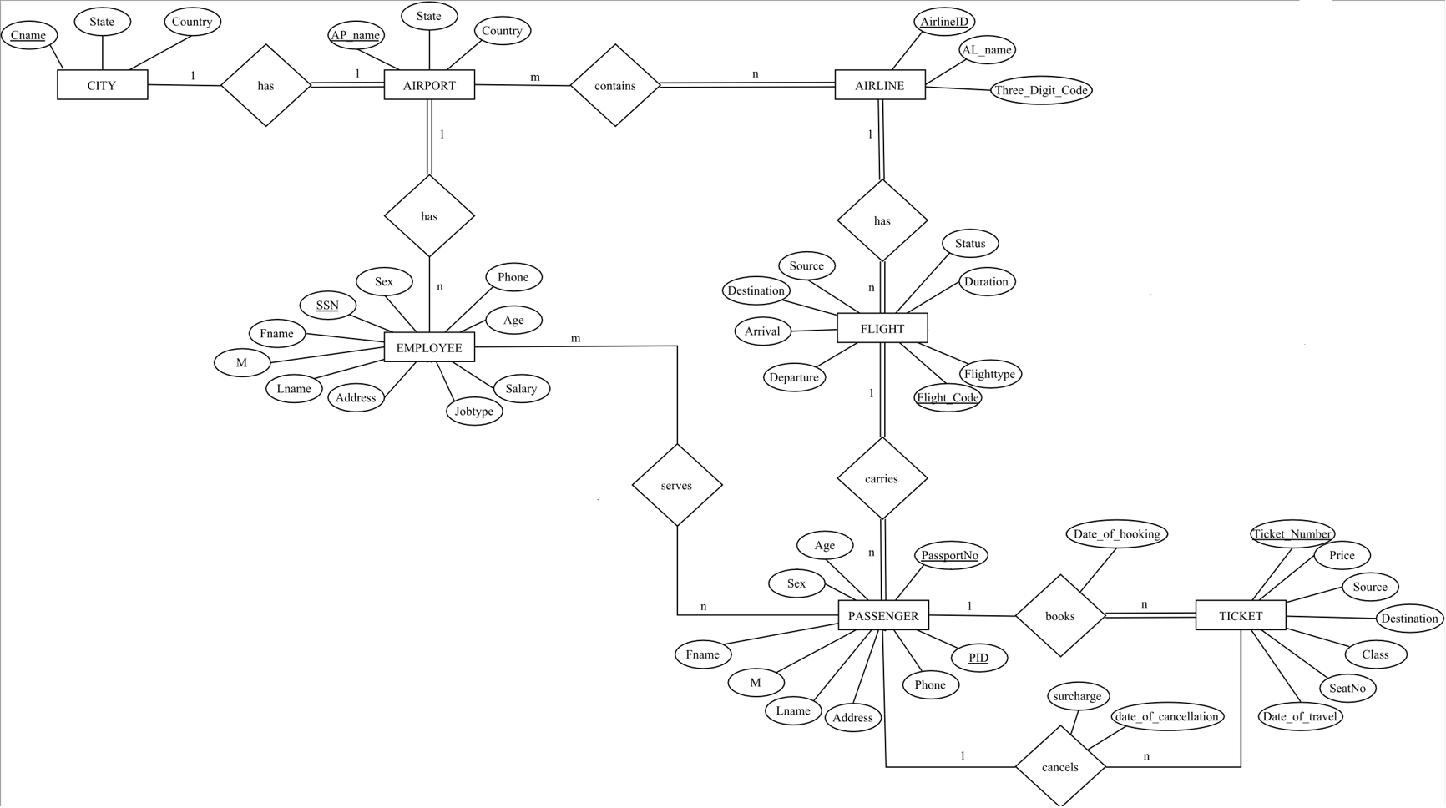

**ER- RELATIONSHIP:**

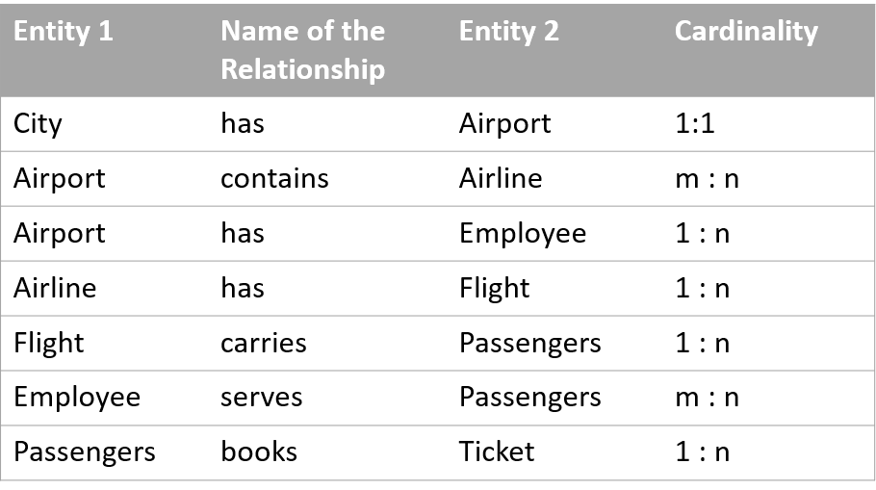

**RELATIONAL DIAGRAM:**

**NORMALIZATION RULE:**

|  |  |
| --- | --- |
| **FUNCTIONAL DEPENDECIES** |  |
| PASSPORTNO -> FNAME, M, LNAME, ADDRESS, PHONE, AGE, SEX | Violates 2NF |
| PID -> FLIGHT_CODE | Violates 2NF |
| DATE_OF_BOOKING, SOURCE, DESTINATION, CLASS -> PRICE | Violates 3NF |
| JOBTYPE -> SALARY | Violates 3NF |

**RELATIONAL DIAGRAM AFTER NORMALIZATION:**

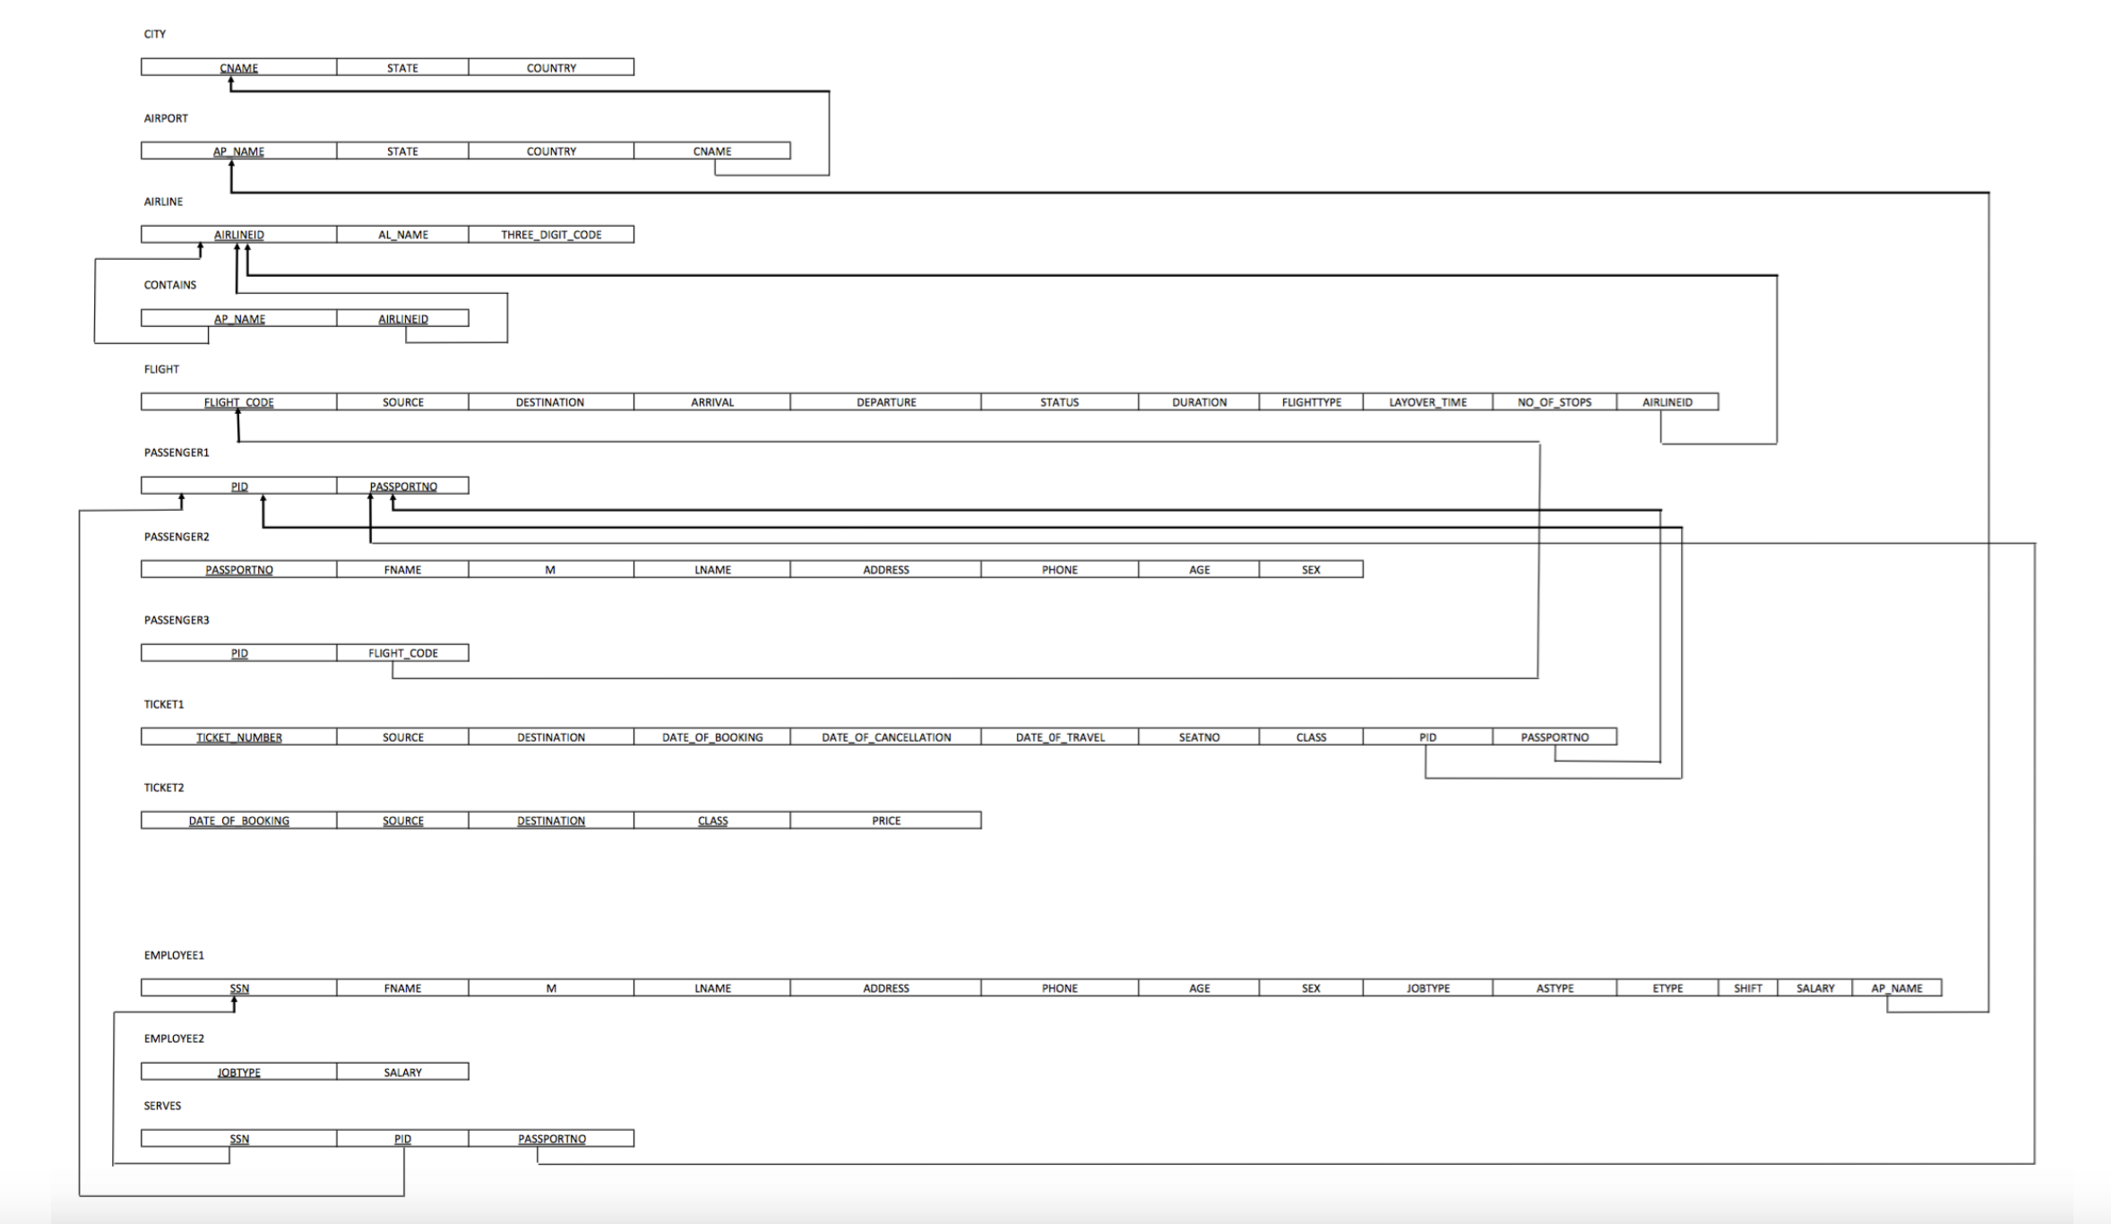

**DATABASE :**

CREATE DATABASE airport_management;

**CITY TABLE :**

CREATE TABLE airport_management.CITY(

CNAME VARCHAR(28) NOT NULL,

STATE VARCHAR(28) NOT NULL,

COUNTRY VARCHAR(28) NOT NULL,

PRIMARY KEY(CNAME)

);

**AIRPORT TABLE :**

CREATE TABLE airport_management.AIRPORT (

AP_NAME VARCHAR(100) NOT NULL,

STATE VARCHAR(28),

COUNTRY VARCHAR(28),

CNAME VARCHAR(28),

PRIMARY KEY (AP_NAME),

FOREIGN KEY (CNAME) REFERENCES CITY (CNAME) ON DELETE CASCADE

);

**AIRLINE TABLE :**

CREATE TABLE airport_management.AIRLINE

(AIRLINEID VARCHAR(3) NOT NULL,

AL_NAME VARCHAR(50),

THREE_DIGIT_CODE VARCHAR(3),

PRIMARY KEY(AIRLINEID)

);

**CONTAINS TABLE :**

CREATE TABLE airport_management.CONTAINS

(AIRLINEID VARCHAR(3) NOT NULL,

AP_NAME VARCHAR(100) NOT NULL,

PRIMARY KEY(AIRLINEID, AP_NAME),

FOREIGN KEY(AIRLINEID) REFERENCES AIRLINE(AIRLINEID) ON DELETE CASCADE,

FOREIGN KEY(AP_NAME) REFERENCES AIRPORT(AP_NAME) ON DELETE CASCADE);

**FLIGHT TABLE :**

CREATE TABLE airport_management.FLIGHT

(FLIGHT_CODE VARCHAR(10) NOT NULL,

SOURCE VARCHAR(3),

DESTINATION VARCHAR(3),

ARRIVAL DATETIME,

DEPARTURE DATETIME,

STATUS ENUM('on-time', 'delayed'),

DURATION VARCHAR(30),

FLIGHTTYPE ENUM('connecting', 'non-stop'),

AIRLINEID VARCHAR(3),

PRIMARY KEY(FLIGHT_CODE),

FOREIGN KEY(AIRLINEID) REFERENCES AIRLINE(AIRLINEID) ON DELETE CASCADE);

**EMPLOYEE1 TABLE :**

CREATE TABLE airport_management.EMPLOYEE1 (

SSN INT NOT NULL AUTO_INCREMENT,

FNAME VARCHAR(20),

MNAME VARCHAR(20),

LNAME VARCHAR(20),

ADDRESS VARCHAR(100),

PHONE INT,

AGE INT CHECK (AGE < 60),

SEX ENUM('M', 'F'),

JOBTYPE VARCHAR(30),

AP_NAME VARCHAR(100),

PRIMARY KEY(SSN),

FOREIGN KEY(AP_NAME) REFERENCES AIRPORT(AP_NAME) ON DELETE CASCADE);

**EMPLOYEE2 TABLE :**

CREATE TABLE airport_management.EMPLOYEE2 (

JOBTYPE VARCHAR(30) NOT NULL,

SALARY INT,

PRIMARY KEY(JOBTYPE));

**SERVES TABLE :**

CREATE TABLE airport_management.SERVES

(SSN INT NOT NULL,

PID INT NOT NULL,

PASSPORTNO VARCHAR(12) NOT NULL,

PRIMARY KEY(SSN, PID, PASSPORTNO),

FOREIGN KEY(SSN) REFERENCES EMPLOYEE1(SSN) ON DELETE CASCADE,

FOREIGN KEY(PID, PASSPORTNO) REFERENCES PASSENGER1(PID, PASSPORTNO) ON DELETE CASCADE);

**TICKET1 TABLE:**

CREATE TABLE airport_management.TICKET1 (

TICKET_NUMBER VARCHAR(20) NOT NULL,

SOURCE VARCHAR(3),

DESTINATION VARCHAR(3),

DATE_OF_BOOKING DATE,

DATE_OF_TRAVEL DATE,

SEATNO VARCHAR(5),

CLASS ENUM('Economy', 'Business', 'First'),

DATE_OF_CANCELLATION DATE,

PID INT AUTO_INCREMENT,

PASSPORTNO VARCHAR(10),

FOREIGN KEY (PID, PASSPORTNO) REFERENCES PASSENGER1 (PID, PASSPORTNO) ON DELETE CASCADE,

CONSTRAINT TICKET_NO_LENGTH CHECK (LENGTH(TICKET_NUMBER) = 13));

**TICKET2 TABLE:**

CREATE TABLE airport_management.TICKET2

(DATE_OF_BOOKING DATE NOT NULL,

SOURCE VARCHAR(3) NOT NULL,

DESTINATION VARCHAR(3) NOT NULL,

CLASS ENUM('Economy', 'Business', 'First') NOT NULL,

PRICE INT,

PRIMARY KEY(DATE_OF_BOOKING, SOURCE, DESTINATION, CLASS));

**TICKET 3 TABLE:**

CREATE TABLE airport_management.TICKET3 (

DATE_OF_CANCELLATION DATE NOT NULL,

SURCHARGE INT,

PRIMARY KEY(DATE_OF_CANCELLATION));

**PASSENGER1 TABLE:**

CREATE TABLE airport_management.TICKET3 (

DATE_OF_CANCELLATION DATE NOT NULL,

SURCHARGE INT,

PRIMARY KEY(DATE_OF_CANCELLATION));

**PASSENGER2 TABLE:**

CREATE TABLE airport_management.PASSENGER2 (

PASSPORTNO VARCHAR(10) NOT NULL,

FNAME VARCHAR(20),

Mname VARCHAR(20),

LNAME VARCHAR(20),

ADDRESS VARCHAR(100),

PHONE INT,

AGE INT,

SEX ENUM('M', 'F'),

PRIMARY KEY(PASSPORTNO));

**PASSENGER3 TABLE:**

CREATE TABLE airport_management.PASSENGER3 (

PID INT NOT NULL,

FLIGHT_CODE VARCHAR(10),

PRIMARY KEY(PID),

FOREIGN KEY(FLIGHT_CODE) REFERENCES FLIGHT(FLIGHT_CODE) ON DELETE CASCADE);

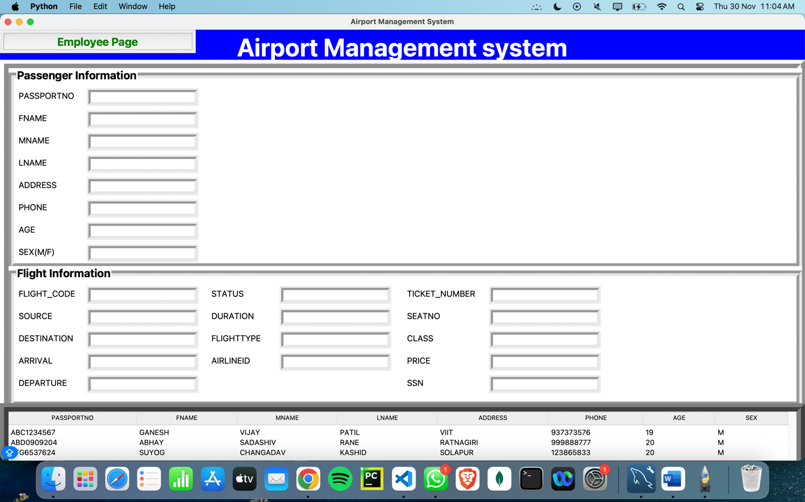

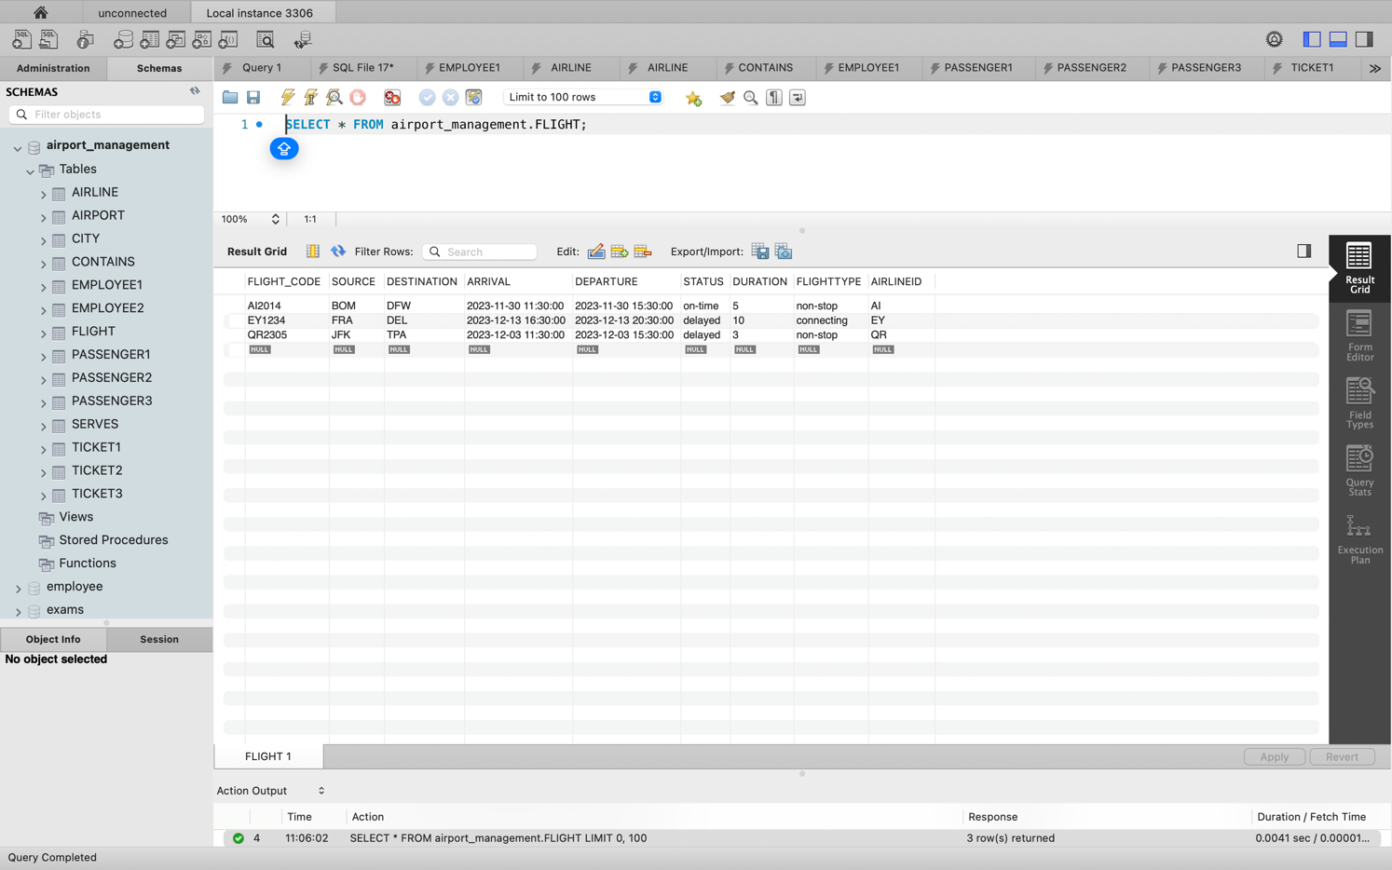

**CONCLUSION:**

A comprehensive Airport Management System (AMS) is pivotal in ensuring smooth operations, efficient services, and enhanced passenger experience within airports. In this DBMS report, the fundamental importance and functionalities of an AMS have been extensively explored and analyzed.

In conclusion, the implementation of a well-designed DBMS in an Airport Management System is indispensable for modern airports to meet the demands of a dynamic aviation industry. The ability to efficiently collect, manage, and utilize data plays a pivotal role in ensuring operational excellence, passenger satisfaction, and the overall success of airport operations. It is crucial for airports to continually adapt and evolve their database management systems to meet the ever-changing needs and advancements in technology within the aviation sector

**REFERENCES:**

[IATA - Codes - Airline and Airport Codes Search](https://www.iata.org/en/publications/directories/code-search/)

[Airport Management System | PDF | Airport | Databases (scribd.com)](https://www.scribd.com/doc/39447569/Airport-Management-System)

[Class diagram for Airport management System - GeeksforGeeks](https://www.geeksforgeeks.org/class-diagram-for-airport-management-system/)

[(PDF) Total Airport Management (Operational Concept and Logical Architectur) (researchgate.net)](https://www.researchgate.net/publication/224997997_Total_Airport_Management_Operational_Concept_and_Logical_Architectur)

[What is Airport Management System? | AltexSoft](https://www.altexsoft.com/glossary/airport-management-system/)

[Airport management systems (amadeus.com)](https://amadeus.com/en/portfolio.airports.airport-management-solutions)